EQUATOR RESOLUTION
Engineering Handoff — Family & Marital vertical

Technical Architecture & Data Specification
System design, data model, sequence flows and API contract

Family & Marital Dispute Resolution vertical
July 2026 · Draft for legal sign-off · www.equatorresolution.com

Purpose & scope
This document specifies the architecture and data model for the Equator family & marital mediation platform. It is the engineering counterpart to the Master Blueprint and is delivered with three machine-readable artefacts: `openapi_fam.yaml` (the API contract, 23 endpoints), `schema_fam.sql` (the PostgreSQL DDL, 21 tables), and the UI Wireframe Kit. Design principles: safety-first, confidentiality by construction, API-first, auditable, and DPDP-compliant by default.
Three non-negotiables
(1) A safety flag from screening must technically prevent a joint session being scheduled. (2) Caucus notes are sealed — encrypted and never readable across parties (Mediation Act, s.22). (3) Every AI answer carries a not-advice disclaimer and provenance; no AI output is final without human review.

1. Logical architecture
A modular service layer behind an API gateway, serving a web/mobile client, with an AI service and external integrations. Services are independently deployable and communicate over authenticated internal APIs with an event bus for audit and notifications.
Service | Responsibility | Key data
Identity & KYC | Authentication, party identity, DPDP consent capture and withdrawal | party, consent_record
Case & workflow | Case lifecycle, state machine, SLAs, case numbering | mediation_case, case_party, case_sla
Screening & safety | Confidential per-party screening; safety flag; safeguards | screening
Panel & appointment | Neutral roster, filters, conflict checks, disclosures, challenges | neutral, appointment
Sessions & case room | Scheduling, video, joint/caucus/shuttle modes, sealed notes | session, caucus_note
Documents | Form rendering, versioning, hashing, e-Sign and e-Stamp orchestration | document
Settlement | MSA assembly, s.20 registration, obligations & compliance tracking | settlement, settlement_obligation
Escrow & payments | Escrow instructions, milestone release, reconciliation | escrow, escrow_milestone, payment_txn
Court interface | Referral linkage (s.89 CPC / Family Courts Act), report filing | court_referral
AI service | RAG retrieval, route/rights answers, drafting, guardrails | ai_interaction
Notification | Email/SMS/WhatsApp with consent; reminders | (event-driven)
Audit & reporting | Tamper-evident event log, MIS, statutory returns | audit_event

2. Sequence flows
The four canonical flows below define the contract between the client, services and external providers. Each numbered message maps to an endpoint in `openapi_fam.yaml`.
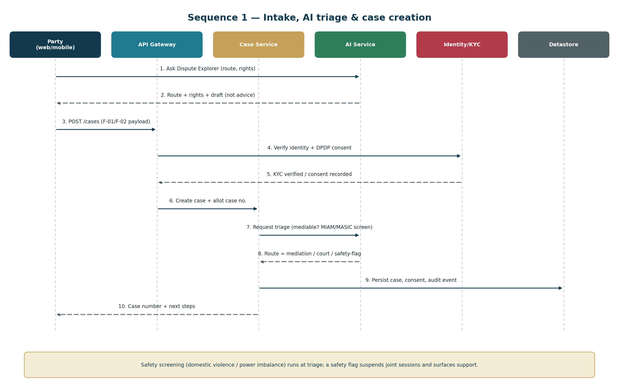
Sequence 1 — intake, AI triage and case creation, with safety screening at triage.

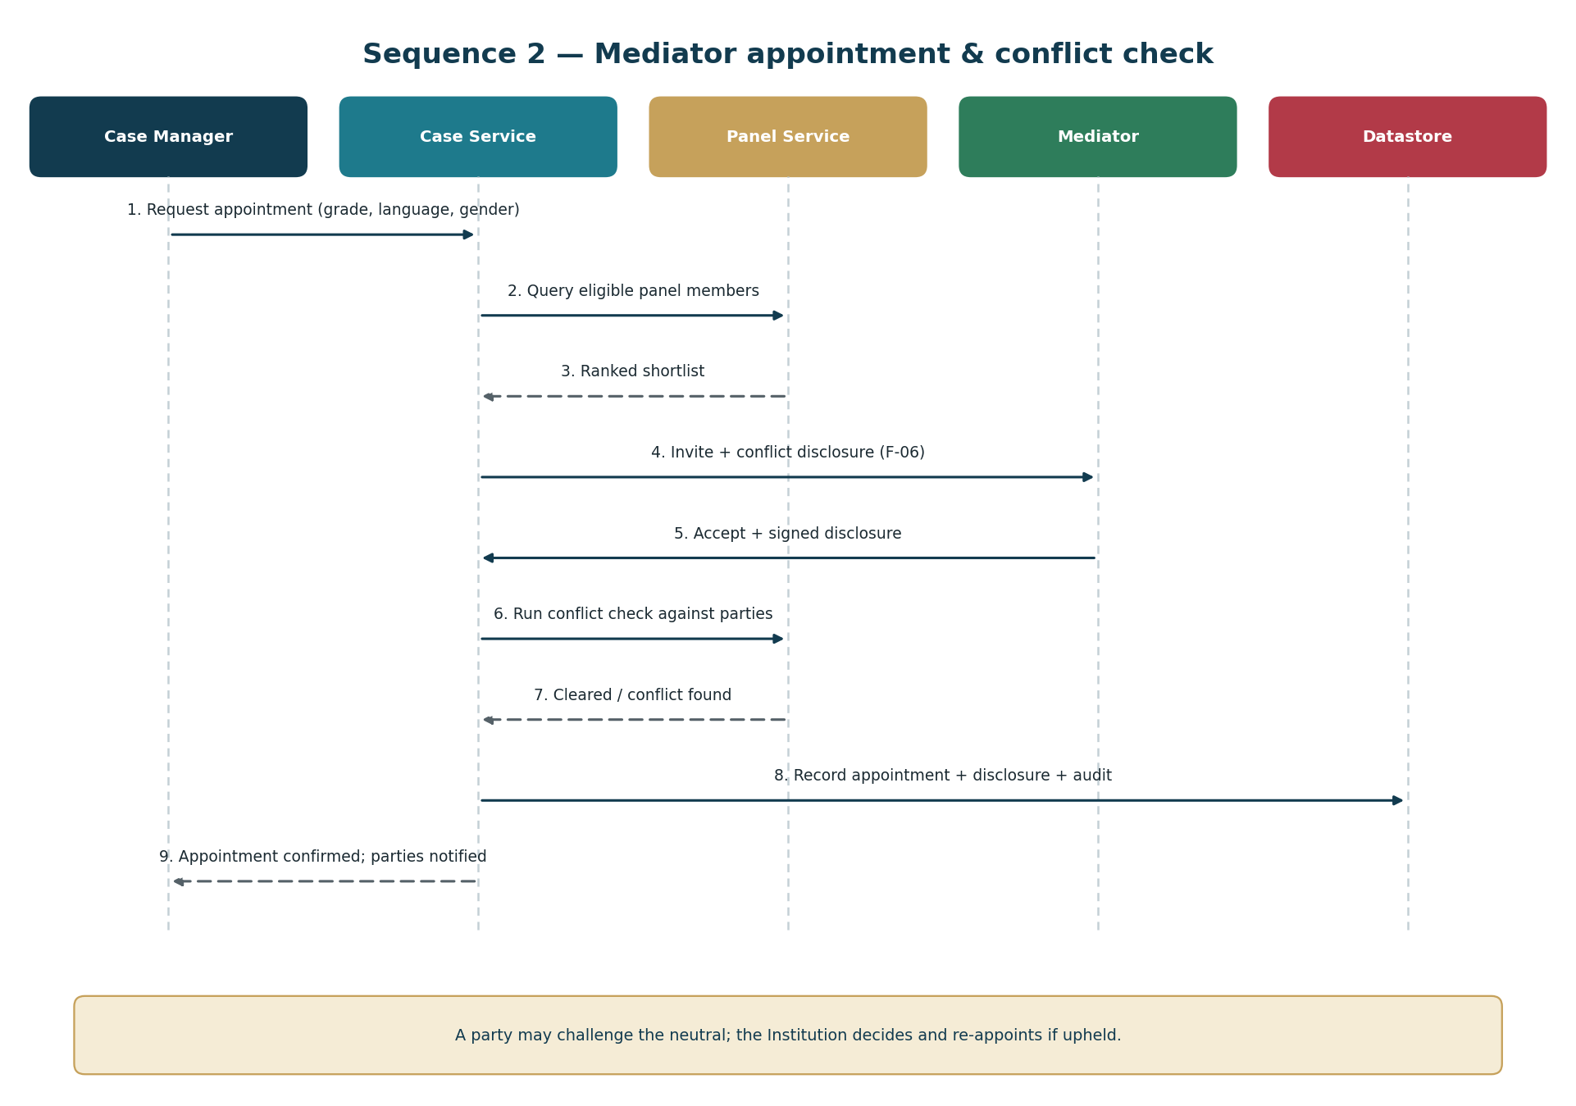
Sequence 2 — mediator appointment, conflict check and disclosure.
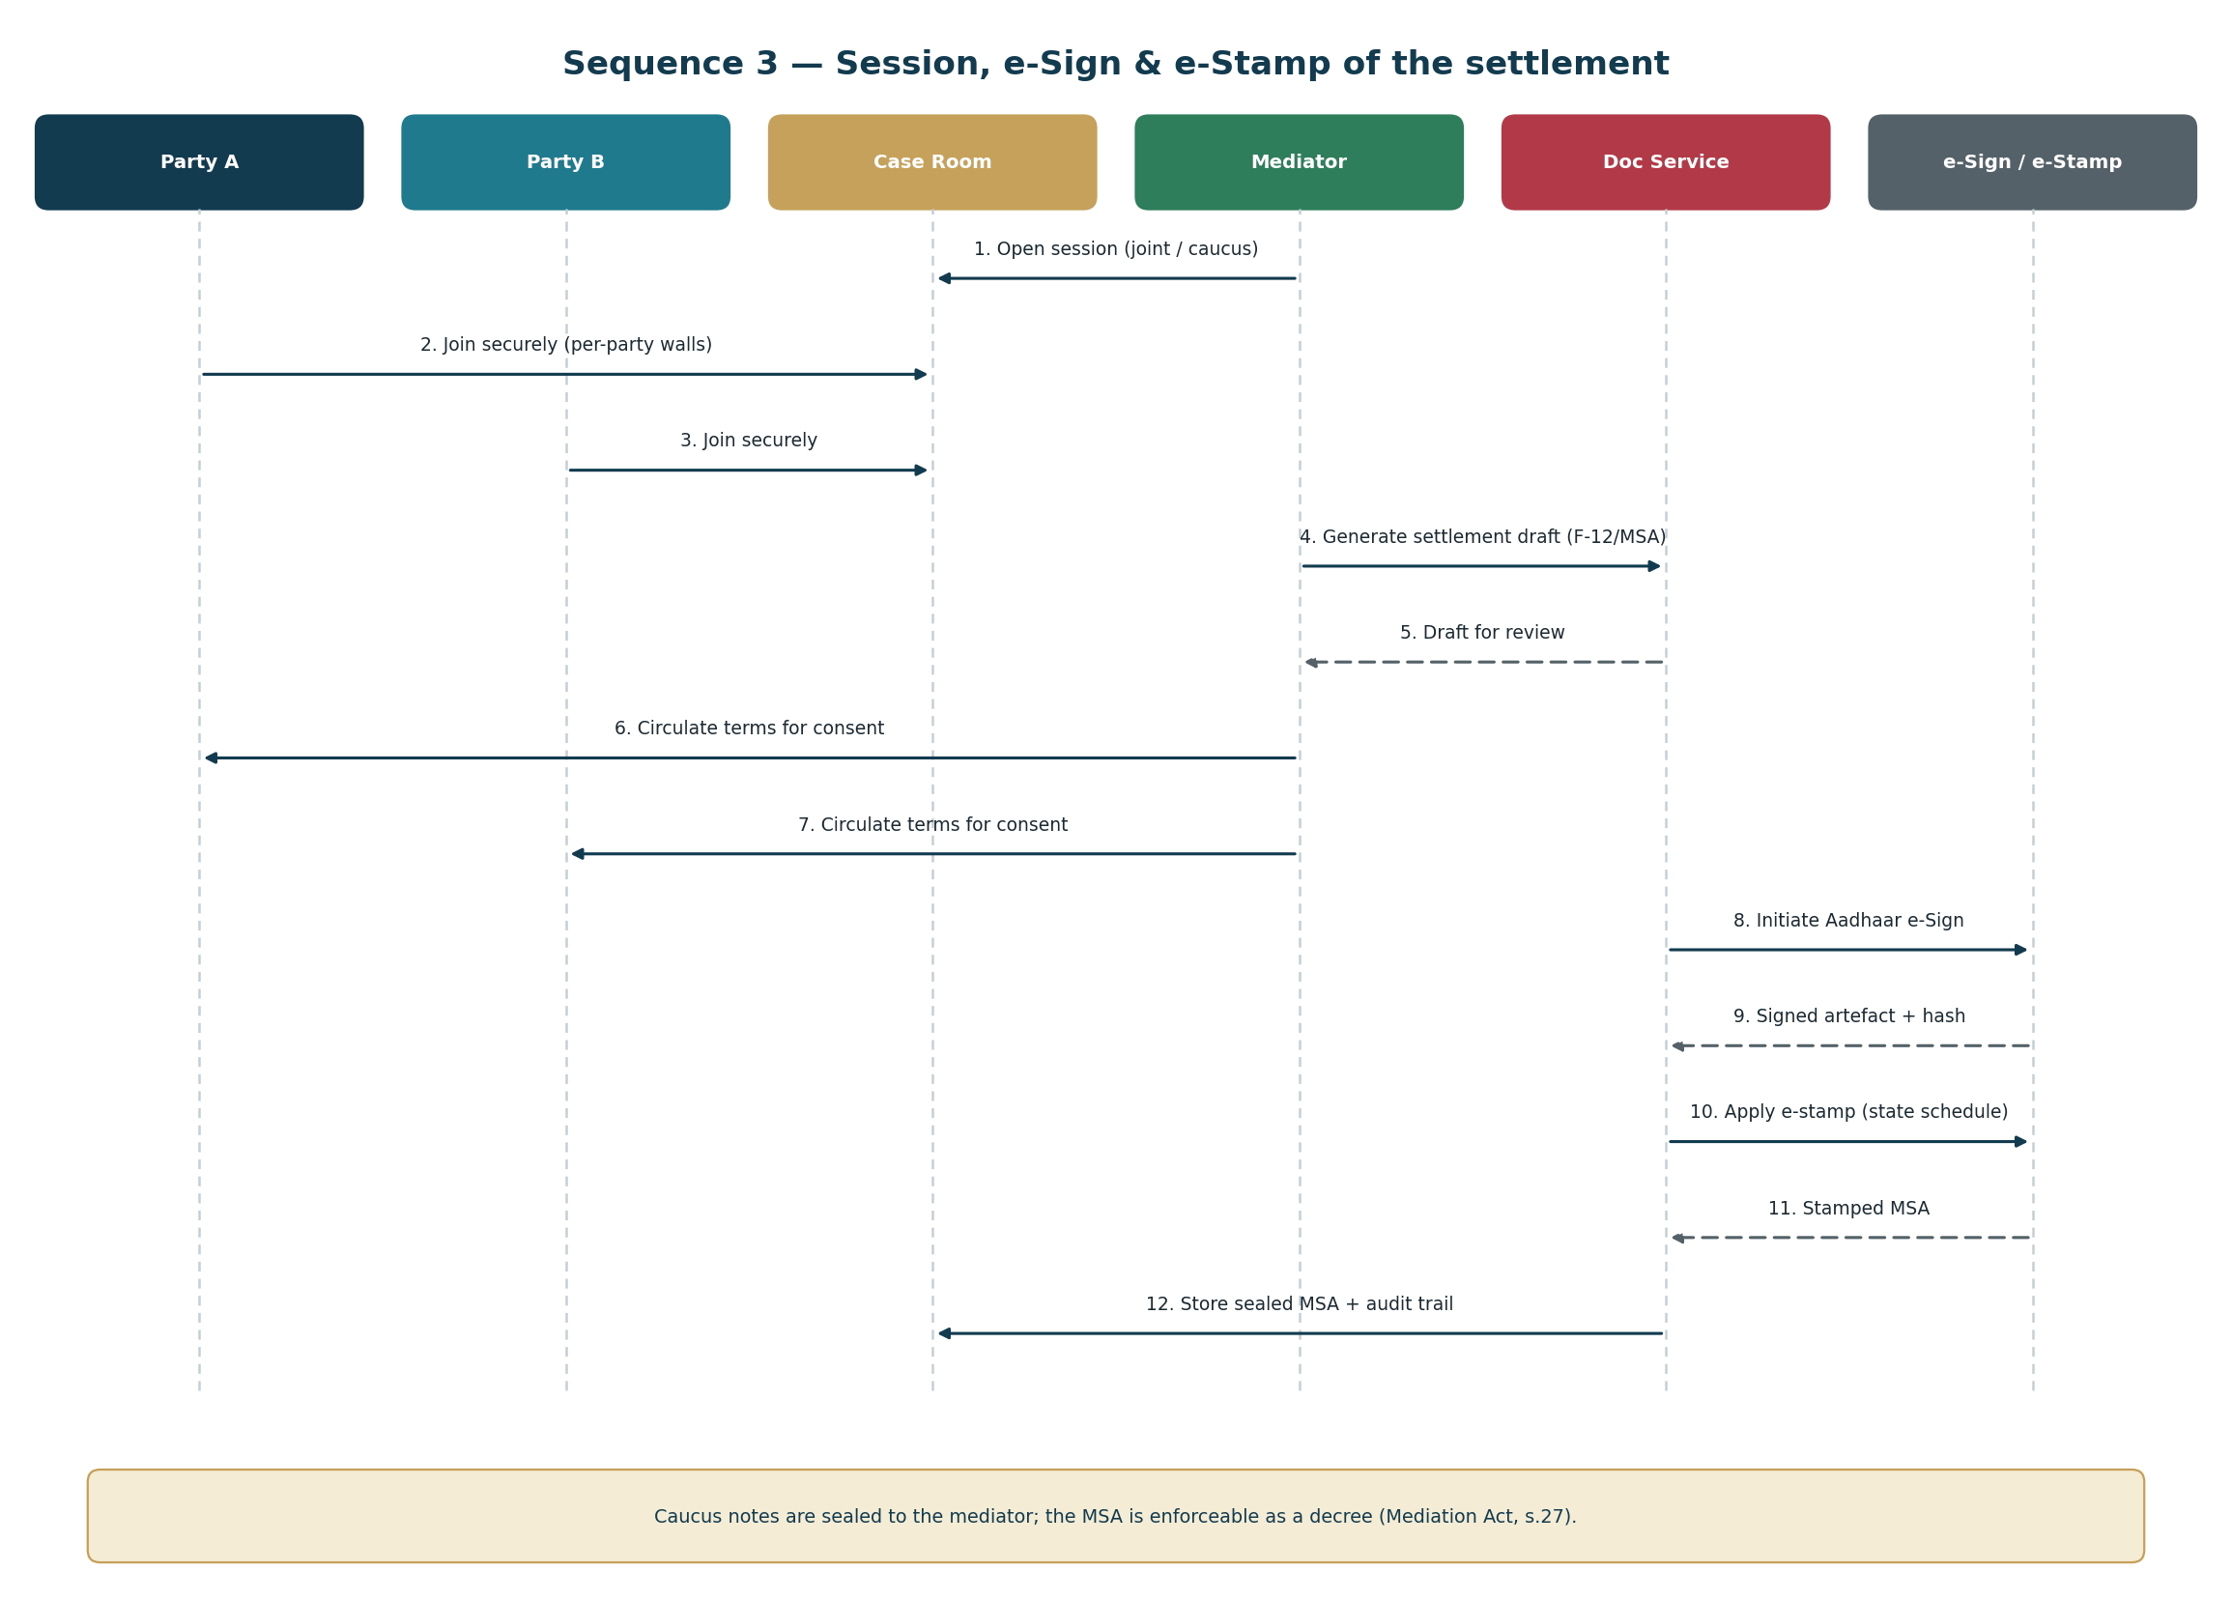
Sequence 3 — session, settlement drafting, Aadhaar e-Sign and e-Stamp.

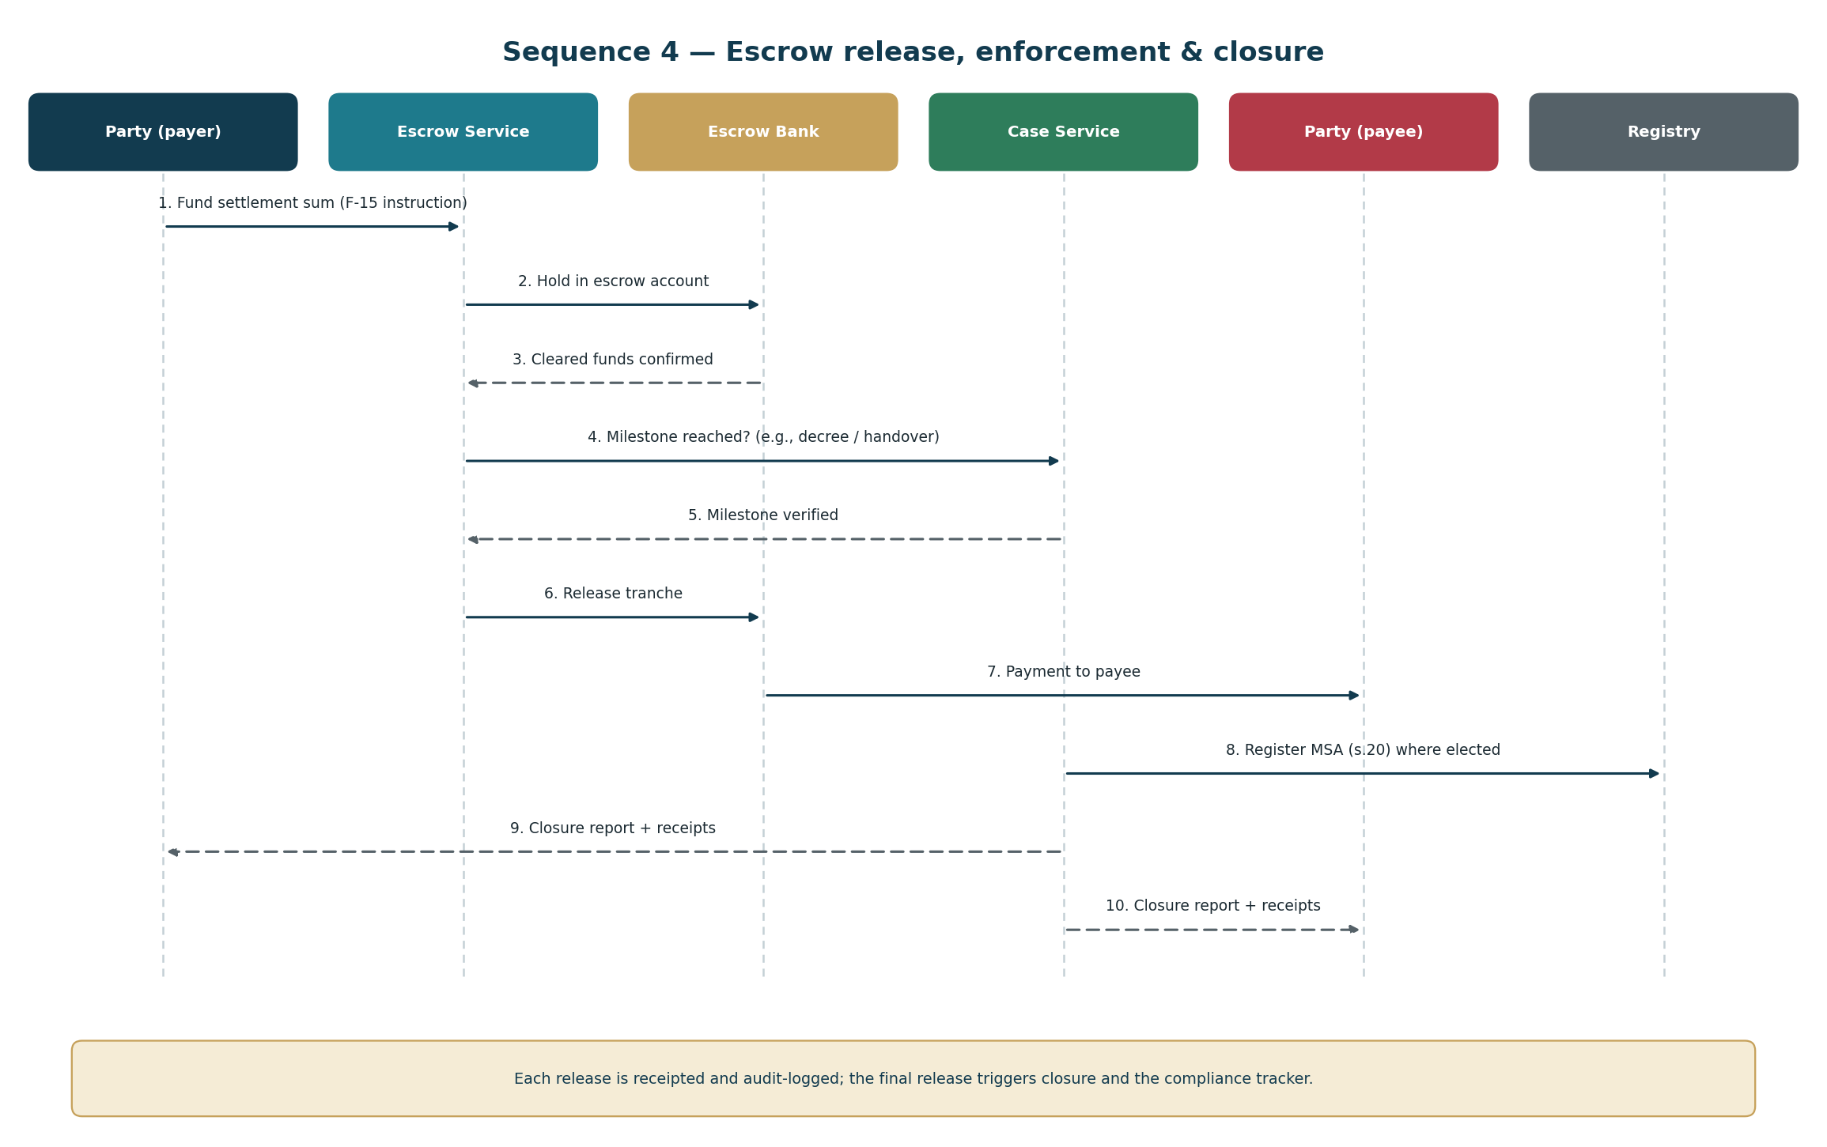
Sequence 4 — escrow funding, milestone release, registration and closure.
3. Data model
The full DDL is delivered as `schema_fam.sql` (PostgreSQL, 21 tables, 11 enumerated types). The model is organised around six clusters:
Cluster | Tables | Notes
Parties & consent | party, consent_record, case_party, child | Identifiers tokenised; children recorded by initials and age only
Case & safety | mediation_case, screening, case_sla | safety_flag gates joint sessions; screening is per-party and confidential
Panel | neutral, appointment | Conflict check and signed disclosure required before activation
Process | session, caucus_note, document | caucus_note stores ciphertext only (BYTEA), sealed to the mediator
Outcome | settlement, settlement_obligation, escrow, escrow_milestone, payment_txn, court_referral | Obligations drive the compliance tracker
Governance | ai_interaction, audit_event, retention_policy | Hash-chained audit; retention enforced by policy table

3.1 Data-protection design (DPDP Act, 2023)
- Minimisation — children are identified by initials and age; no raw government IDs are stored, only tokenised references.
- Consent — `consent_record` captures purpose, basis, notice version and withdrawal; withdrawal propagates to processing.
- Sealed data — caucus notes are encrypted at rest with keys scoped to the mediator; no cross-party read path exists.
- Retention — `retention_policy` drives automated purge (caucus notes 12 months; case records 84 months; audit 120 months) — confirm against the DPDP Rules.
- Auditability — `audit_event` is append-only and hash-chained (`prev_hash`/`row_hash`) so tampering is detectable.
4. API contract
`openapi_fam.yaml` (OpenAPI 3.0.3) defines 23 endpoints across 10 tags. Notable design decisions:
- `POST /cases/{id}/sessions` returns 409 Conflict where a safety flag prohibits a joint session — the safety rule is enforced at the API, not merely in the UI.
- `POST /cases/{id}/screening` is per-party and never returns another party's screening content.
- `POST /sessions/{id}/caucus-notes` is mediator-scoped and write-mostly; there is no cross-party read endpoint.
- `POST /ai/explore` always returns `disclaimers`, `citations` (RAG provenance), `isAdvice: false` and `humanEscalationOffered`.
- `POST /settlements/{id}/register` submits the MSA for registration under s.20 of the Mediation Act, 2023; `enforceableS27` records decree-equivalence under s.27.
5. Security architecture
Control | Implementation
Transport & storage | TLS 1.2+; AES-256 at rest; field-level encryption for sealed notes
Identity | MFA for staff, mediators and panel; step-up auth for sealed data
Authorisation | RBAC plus per-case ACLs; confidentiality walls between parties
Key management | HSM/KMS; per-case data keys for caucus material; rotation policy
Audit | Append-only, hash-chained event log; access logging on every read of sensitive data
Application security | SAST/DAST, dependency scanning, quarterly pen-test, patch SLAs
Resilience | Encrypted backups; tested restore; documented RPO ≤1h / RTO ≤4h
Data residency | India-resident storage and processing as applicable

6. Environments, delivery & non-functionals
Separate dev / staging / production; infrastructure-as-code; CI/CD with automated tests plus security and AI-evaluation gates; full observability (logs, metrics, traces). Rollout is staged: internal → closed pilot (one or two courts/partners) → general availability.
Attribute | Target [confirm at build]
Availability | 99.9% for core case services
p95 API latency | < 500 ms (non-AI endpoints)
AI response p95 | < 5 s with streaming
RPO / RTO | ≤ 1 hour / ≤ 4 hours
Concurrent sessions | Horizontally scalable; video via managed provider
Accessibility | WCAG 2.1 AA; vernacular UI

This specification is a draft for engineering and must be reviewed by security, a Data Protection Officer and counsel before build. It is not legal advice.

